**VENDOR PERFORMANCE REPORT**

**EXPLORATORY DATA ANALYSIS**

In the earlier stage, we reviewed the available tables in the dataset to identify key variables, understand their relationships, and determine which should be included in the final analysis.

During the Exploratory Data Analysis (EDA) phase, we will analyze the consolidated table to examine the distribution of each column. This step will help us uncover data patterns, detect anomalies, and validate data quality before proceeding with further analysis.

**SUMMARY STATISTICS**

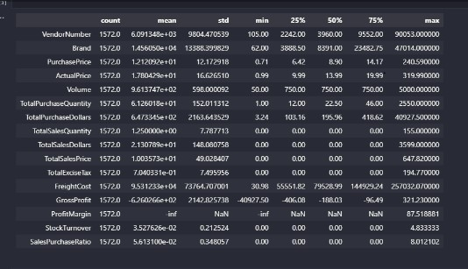

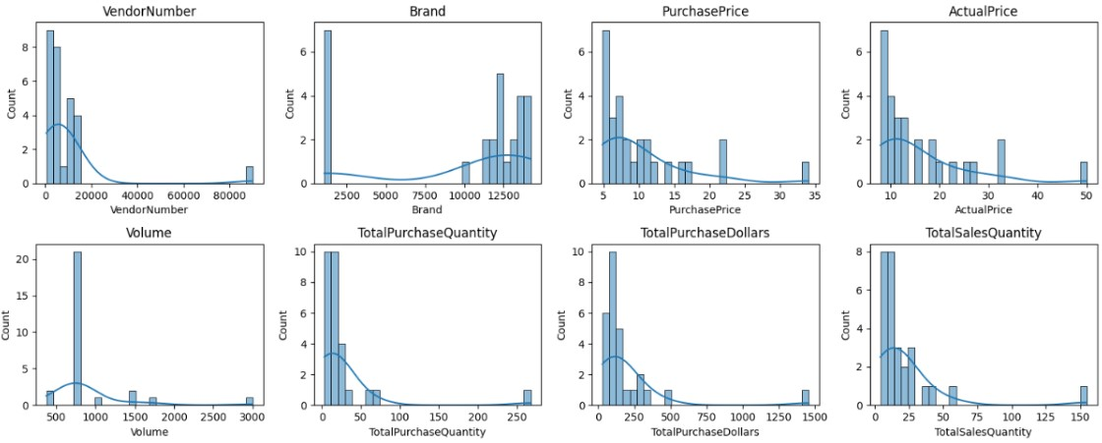

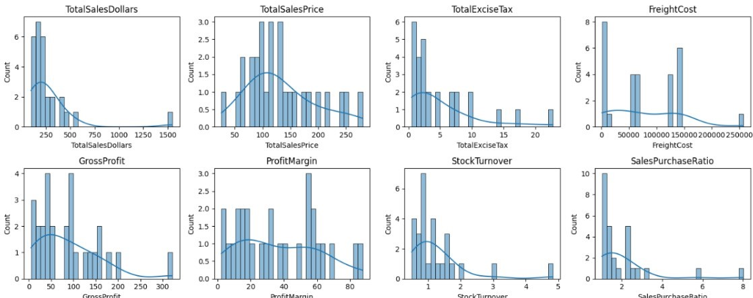

**Summary Statistics Insights**

**Negative & Zero Values**

* **Gross Profit**: The minimum value is negative, indicating losses. This suggests certain products or transactions may be sold at a loss due to high procurement costs or heavy discounting below purchase price.
* **Profit Margin**: The minimum is recorded as negative infinity, which occurs in cases where revenue is zero or lower than the associated costs.
* **Total Sales Quantity & Sales Dollars**: Minimum values are zero, suggesting that some products were purchased but never sold. These may represent slow-moving or obsolete stock.

**Outliers Indicated by High Standard Deviation**

* **Purchase Price & Actual Price**: Maximum values are significantly higher than the mean, pointing to the presence of premium or high-value products.
* **Freight Cost**: A wide variation in costs indicates potential logistics inefficiencies or the impact of bulk shipment charges.
* **Stock Turnover**: High variability suggests some products sell rapidly while others remain in stock indefinitely. A value greater than 1 indicates that sales for a product exceeded its recent purchases, possibly due to fulfilling demand from older inventory.

**Data Filtering**

To enhance the reliability of insights, inconsistent data points were excluded based on the following criteria:

* **Gross Profit ≤ 0**: Transactions resulting in losses were removed.
* **Profit Margin ≤ 0**: Only profitable transactions were retained for analysis.
* **Total Sales Quantity = 0**: Inventory items that were never sold were eliminated.

**Correlation Insights**

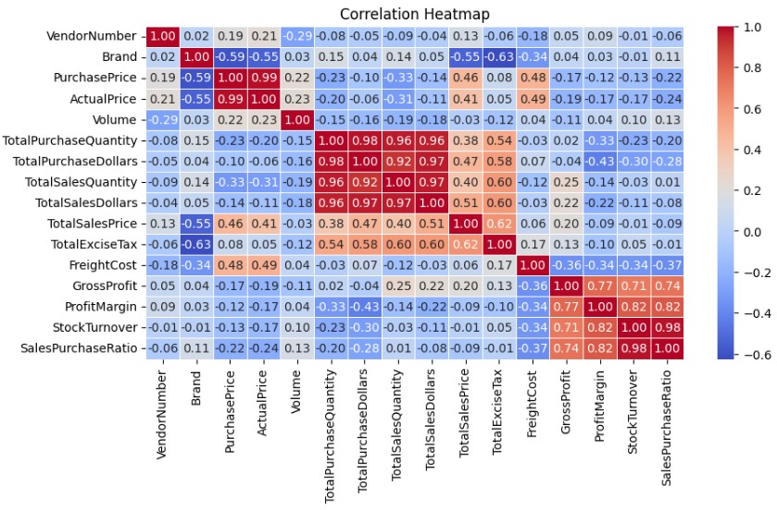

**Correlation Insights**

* Purchase Price shows a weak correlation with both Total Sales Dollars and Gross Profit, indicating that variations in purchase price have minimal impact on sales revenue or profitability.
* A negative correlation between Profit Margin and Sales Price suggests that as sales prices increase, profit margins tend to decline, potentially due to competitive pricing pressures.
* There is a strong positive correlation between Total Purchase Quantity and Total Sales Quantity, confirming efficient inventory turnover.
* Stock Turnover exhibits a weak negative correlation with both Gross Profit and Profit, implying that faster inventory turnover does not necessarily translate into higher profitability.

**Research Questions & Key Findings**

1. **Brands for promotional or Pricing Adjustment**

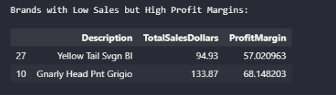

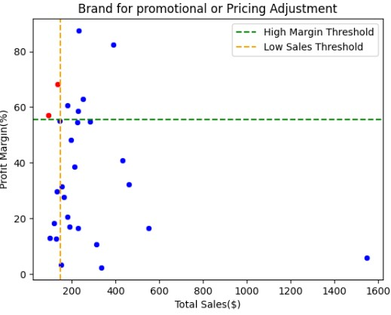

1. **Top Vendors by Sales & Purchase Contribution**

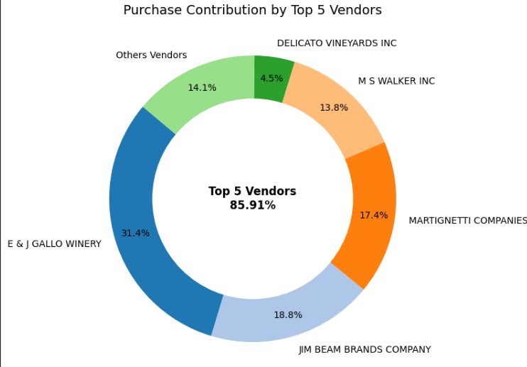

**Impact of Bulk Purchasing on Cost Savings**

Vendors buying in large quantities receive lower unit cost.

Bulk pricing strategies encourage larger orders, increasing total sales while maintaining proitibality

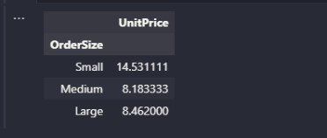

1. **Identifying Vendors with low inventory Turnover**

Slow-moving inventory increase storage costs, reduce cash flow efficiency, and affects overall profitability.

Identifying vendors with low inventory turnover enables better stock management, minimizing financial strain.

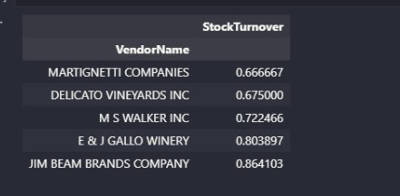

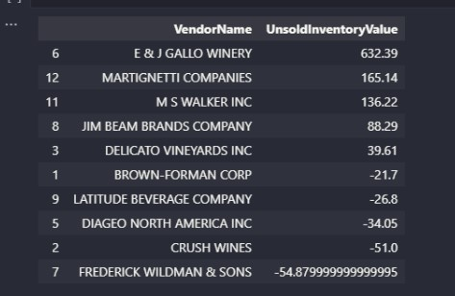

1. **Profit Margin Comparison: High vs. Low-Performing Vendors**

Top Vendors Profit Margin (95% CI): (1.29, 53.21) Mean: 27.25

Low Vendors Profit Margin(95%CI): (14.64, 57.83) Mean: 3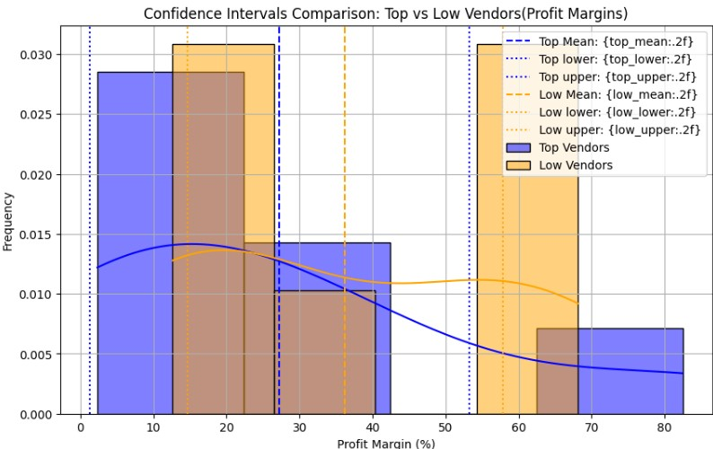6.23

Low- performing vendors maintain higher margins but struggles with sales Volumes, indicating potential pricing inefficiencies or market reach issues.

1. **Statistical Validation of Profit Margin Differences**

**Hypothesis Testing:**

H₀ (Null Hypothesis): There is a significant difference in the margin in the mean profit margin of top performing and low performing vendors.

H₁ (Alternative Hypothesis): The mean profit margin of top performing and low performing vendors are significantly different.

**Result:** T-statistic: -0.6508026183169885, P-value: 0.527838

Fail to reject the null hypothesis: No significant difference in the mean profit margin of top performing and low performing vendors**.**

**Final Recommendations**

* Re-evaluate pricing for low-sales, high-margin brands to boost sales volume without sacrificing profitability.
* Diversity vendor partnerships to reduce dependency on a few suppliers and mitigate supply chain risks.
* Leverage bulk purchasing advantages to maintain competitive pricing while optimizing inventory management.
* Enhance marketing and distribution strategies for low-performing vendors to drive higher sales volumes without compromising profit margins.